Do Experimental Schools Drive Housing Prices?
實驗學校是否推動房價上漲？
Comparing Housing Price Trends Near Public Experimental Schools
vs. Regular Public Schools in Taipei
Radek Matloch (113266016) | Bernard Kwizera (114266019)
Big Data and Social Analysis | ICI, National Chengchi University | 2026
Abstract
This study looks at whether housing prices near public experimental schools in Taipei have changed differently compared to prices near regular public schools after the schools converted to experimental status. Using 170,551 real estate transactions from 2015 to 2023 and the geocoded locations of 9 experimental and 103 regular schools, we compare price trends within natural catchment zones in the same districts. At the overall level, properties near experimental and regular schools show similar price trends, with the gap narrowing over time. The difference-in-differences analysis on 5 schools with sufficient data shows that 3 out of 5 schools (Binjiang +9.9%, Fanghe +4.1%, Xihu +2.2%) had experimental areas appreciating faster than regular areas after conversion. Two schools (Bojia -9.2%, Quanyuan -30.2%) showed the opposite. We cannot claim that experimental schools cause price changes, but the results suggest that the effect depends strongly on the school's location within its district.
Keywords: experimental schools, housing prices, Taipei, proximity analysis, school district premium, difference-in-differences

1. Introduction
In recent years, Taipei has set up about 10 public experimental elementary and junior high schools. These schools were created under Taiwan's Experimental Education Act, passed in 2014. They use alternative teaching approaches like Montessori, Waldorf, and project-based learning, but remain free public schools. Parents actively try to enroll their children in these schools, which raises the question: does this demand affect nearby housing prices?
In Taiwan, the school district system means families often move to be near a preferred school. This creates a possible link between school desirability and local real estate prices. While this connection is well studied in other countries, the specific effect of experimental school conversions in Taiwan has not been looked at before.
Our research question is: Have housing prices near public experimental schools in Taipei increased faster than prices near comparable regular public schools since the schools converted to experimental status?

2. Data Sources

2.1 Real Estate Transactions
We downloaded transaction data from Taiwan's Ministry of the Interior Real Price Registration System (plvr.land.moi.gov.tw). We collected 36 quarterly CSV files covering 2015 to 2023, filtered to Taipei City sales transactions. After cleaning, the dataset contains 170,551 transactions across all 12 Taipei districts. Key variables include district, full street address, unit price per square meter, transaction date, building type, number of rooms, building age, and floor level.

2.2 School Locations and Status
We built the school dataset from K12 Education Administration yearly school lists, data.gov.tw school directories (datasets 6087 and 6089), and Google Maps. The dataset includes 9 experimental schools that converted between 2017 and 2022, plus 103 regular public schools in the same 6 districts. Experimental school coordinates were looked up manually on Google Maps. Regular school coordinates were geocoded using the Google Maps Geocoding API.

School | District | Level | Year | In DiD? | Notes
博嘉實驗國小 | 文山區 | Elementary | 2017 | Yes
泉源實驗國小 | 北投區 | Elementary | 2018 | Yes | Mountain area
芳和實驗中學 | 大安區 | Secondary | 2018 | Yes
溪山實驗國小 | 士林區 | Elementary | 2019 | No | Too few transactions
湖田實驗國小 | 士林區 | Elementary | 2019 | No | Yangmingshan
民族實驗國中 | 大安區 | Junior High | 2019 | No | Too few transactions
濱江實驗國中 | 中山區 | Junior High | 2020 | Yes
指南實驗國小 | 文山區 | Elementary | 2022 | No | Too few transactions
西湖實驗國中 | 內湖區 | Junior High | 2022 | Yes
Table 1: Experimental schools and their inclusion in the analysis

3. Methods

3.1 Geocoding
Experimental school coordinates were looked up manually on Google Maps. Regular school addresses were geocoded using the Google Maps Geocoding API. For real estate transactions, we extracted 1,649 unique road names from the address column and geocoded them using OpenStreetMap Nominatim, with a 92% success rate (1,509 out of 1,649 roads). Each property was given the coordinates of its road center. This is not exact but is accurate enough for a 1km radius comparison.

3.2 Catchment Zones
For each property in the six experimental school districts, we calculated the distance to the nearest experimental school and the nearest regular school in the same district using the Haversine formula. Each property was then tagged based on which school was closer. This creates natural catchment zones around each school. Because we only compare within the same district, price differences between cheap and expensive parts of Taipei are greatly reduced. We used a 1km radius to keep the comparison tight and reduce noise from distant properties.

3.3 Analysis Approaches
We used four approaches: (1) Overall comparison of median prices between experimental and regular catchment zones over time. (2) Per-school analysis comparing each experimental school to nearby regular schools. (3) Matched comparison using only 2 to 4 room apartments to control for property type. (4) Difference-in-differences comparing price growth rates before and after each school's conversion date.
Four schools (Xishan, Hutian, Minzu, Zhinan) were excluded from the per-school and DiD analysis because they had too few transactions within the 1km radius to produce reliable results. This left 5 schools for detailed analysis.

3.4 Tools
All analysis was done in R 4.4.1 using tidyverse (dplyr, ggplot2, tidyr, lubridate, readr), geosphere for distance calculations, and tidygeocoder for geocoding.

4. Results

4.1 District Price Overview
Figure 1 shows median housing prices by district over time. Da'an and Zhongzheng are the most expensive districts, while Beitou, Wenshan, and Shilin, where most experimental schools are located, rank among the cheapest. This price gap is why we use within-district proximity comparison rather than comparing across districts.
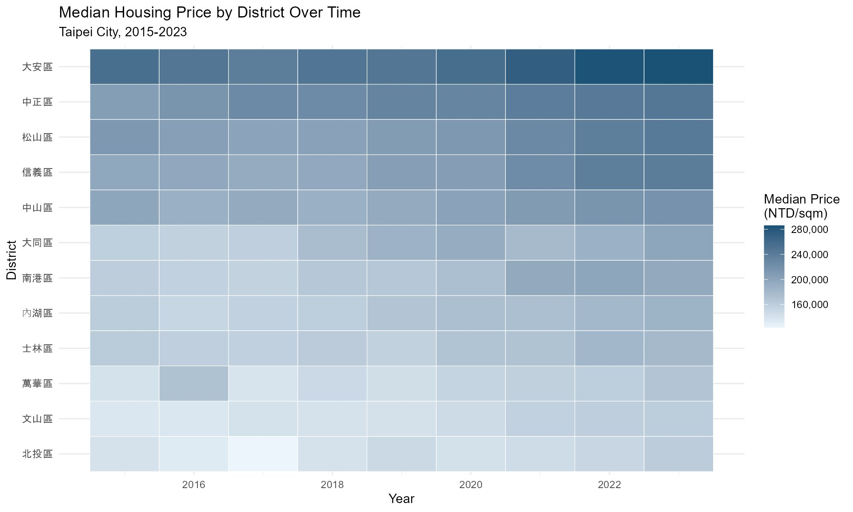
Figure 1: Median housing price by district over time (2015 to 2023)

4.2 Overall Proximity Comparison
Figure 2 shows median unit prices for properties near experimental schools vs. near regular schools within the same district, using a 1km radius. The two lines track very closely throughout the study period. Experimental school areas started slightly higher in 2015, dipped below in 2016 to 2018, then both groups appreciated at similar rates. By 2023 they are nearly identical at about 195,000 NTD per sqm. This shows that at the overall level, there is no large or consistent price premium for experimental school proximity.
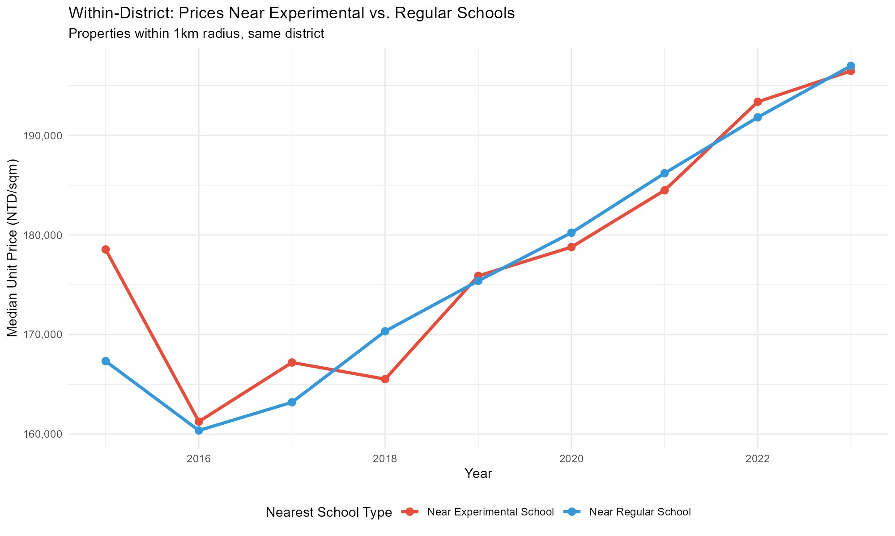
Figure 2: Within-district proximity comparison, 1km radius

4.3 Matched Apartment Comparison
Figure 3 shows the same comparison filtered to only 2 to 4 room apartments. The pattern is similar: both groups appreciate over time, with regular school areas slightly ahead for most of the period. The gap narrows from 2020 onward. By 2023, the difference is about 2%.
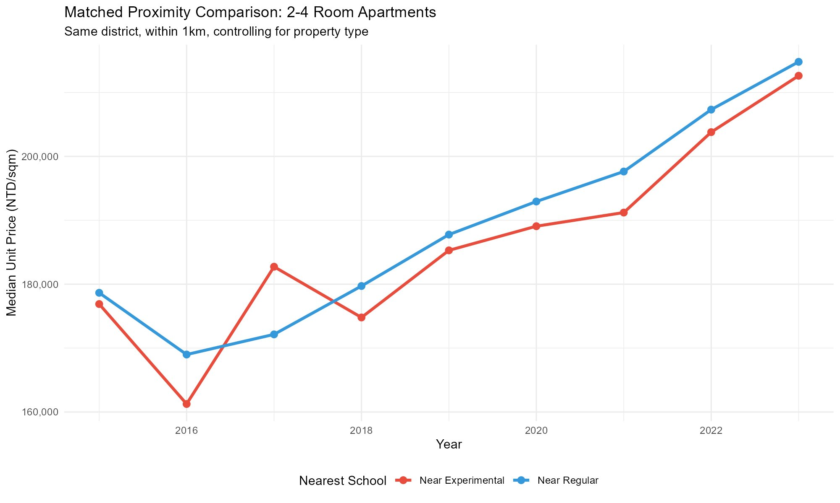
Figure 3: Matched proximity comparison, 2 to 4 room apartments

4.4 Per-School Price Premium
Figure 4 shows the price premium for each of the 5 schools with enough data. All show a negative premium, meaning properties near the experimental school are slightly cheaper than those near the nearest regular school. Xihu shows the smallest gap at about -2%, while Quanyuan shows the largest at about -33%. This reflects the fact that experimental schools tend to be in less central parts of their districts.
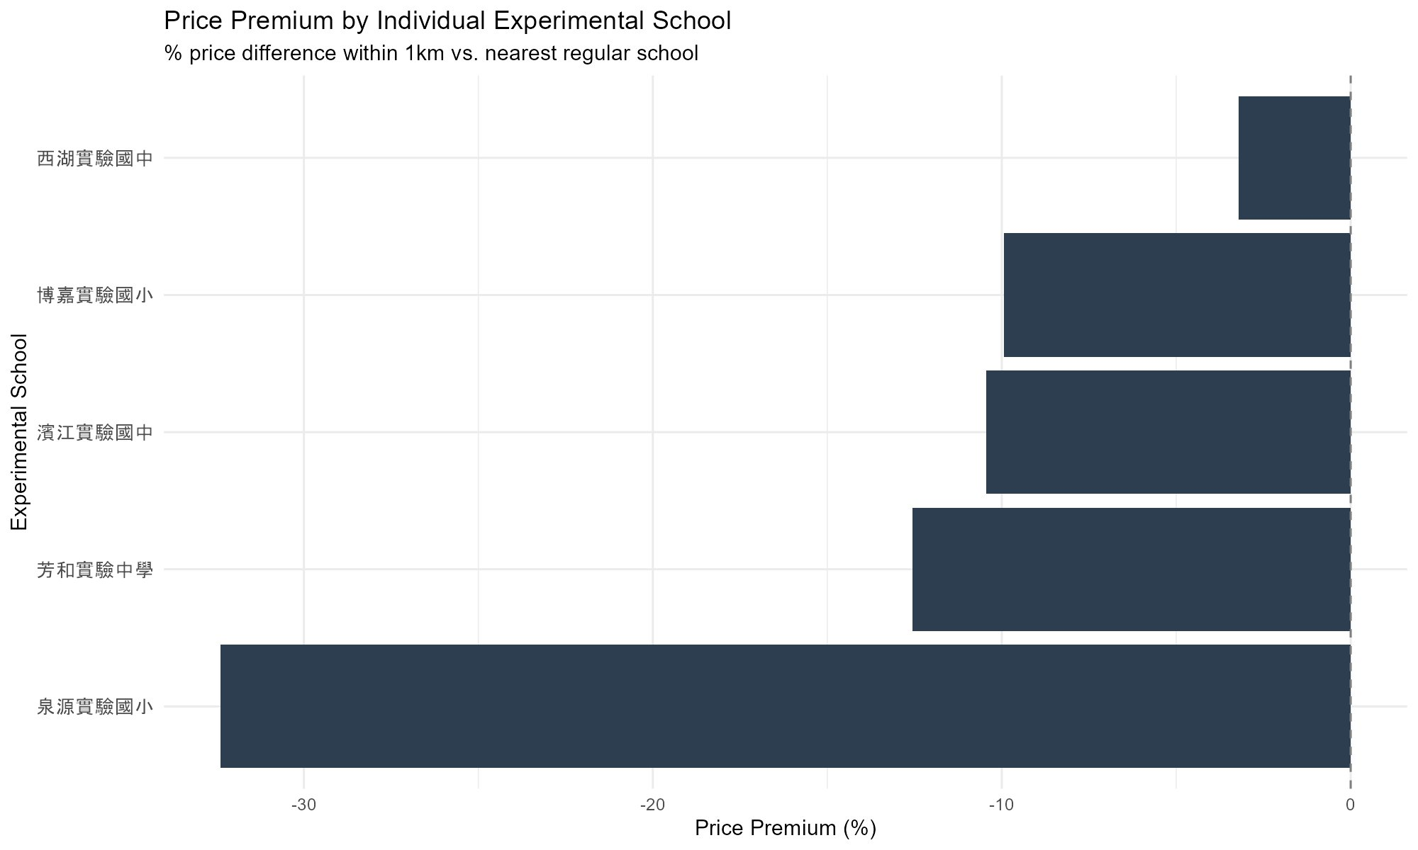
Figure 4: Price premium by individual experimental school (1km radius)

4.5 Yearly Trends by School
Figure 5 shows yearly price trends for each school. Regular school areas (blue) are generally above experimental school areas (red), but the gap is narrowing for most schools. This is most visible for Xihu and Fanghe, where the lines are converging in recent years. Quanyuan shows the most volatile pattern due to few nearby transactions.
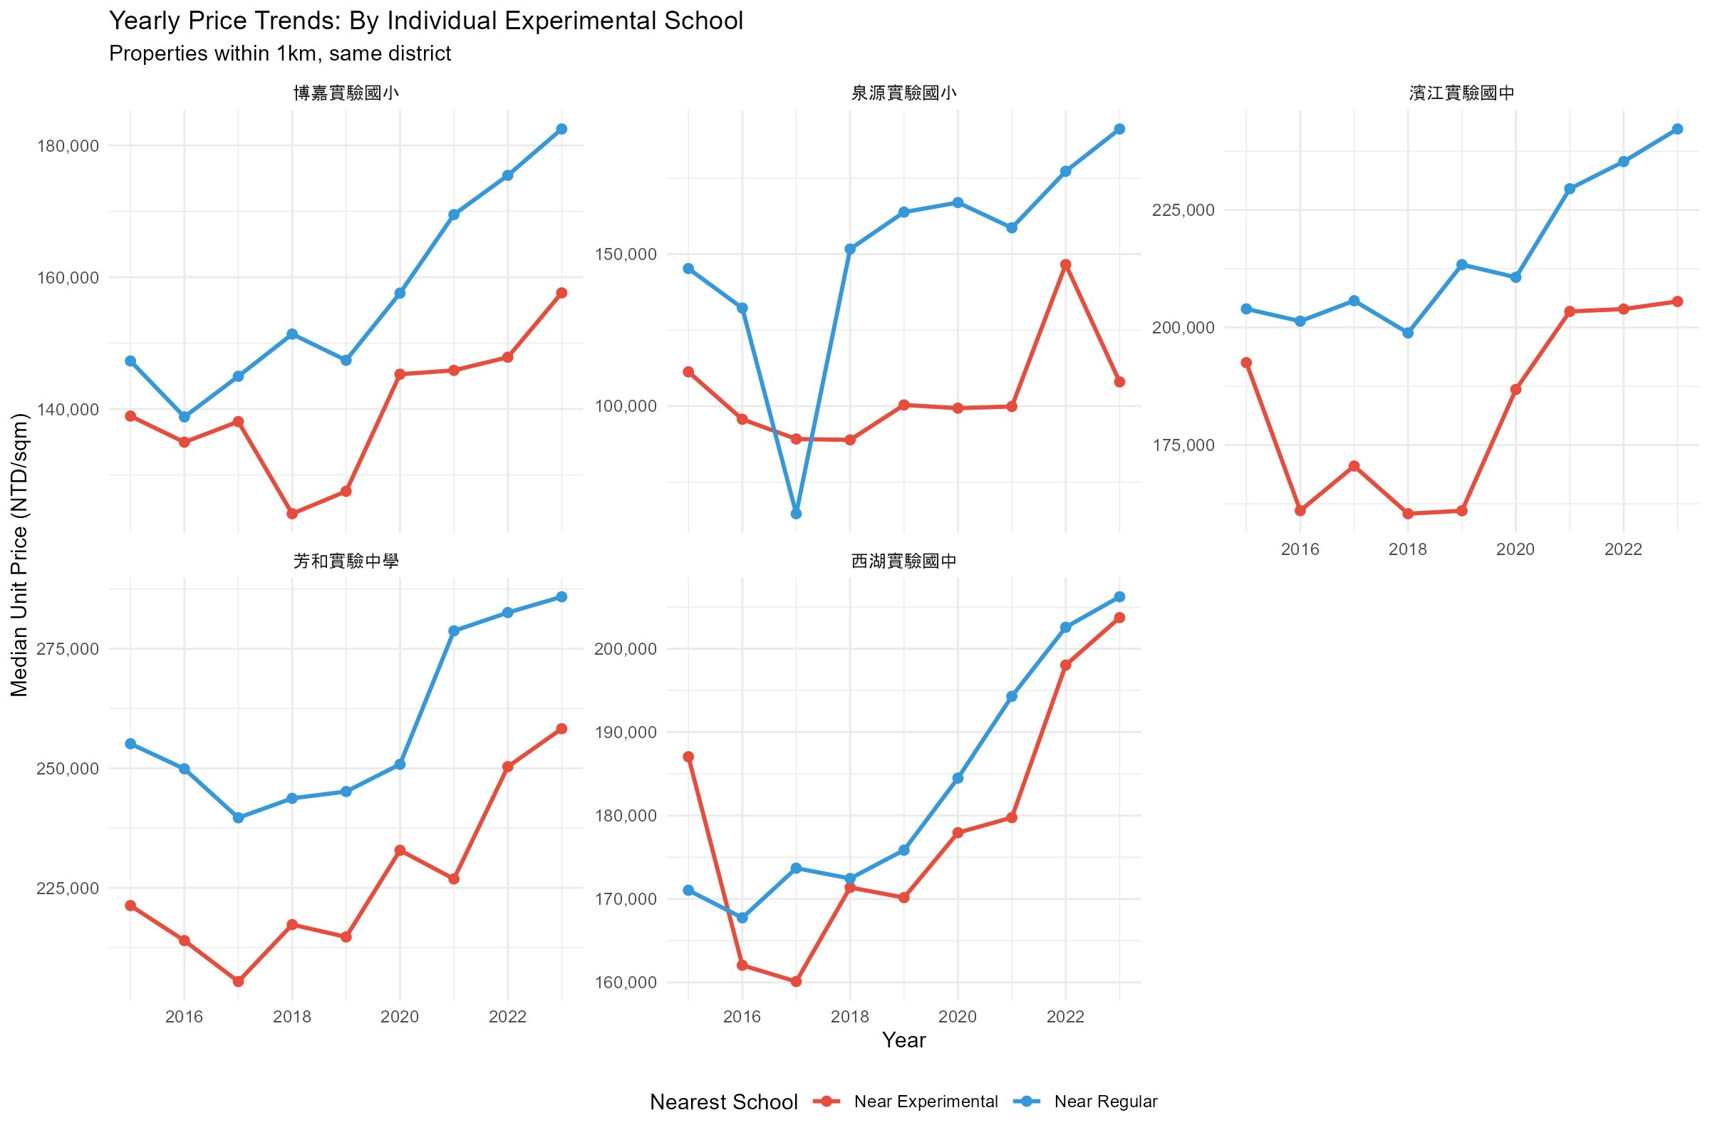
Figure 5: Yearly price trends by individual school

4.6 Before and After School Conversion
Figure 6 shows prices before and after each school's conversion, using only matched 2 to 4 room apartments. Both groups see price increases after conversion, reflecting the overall Taipei market trend. The question is whether experimental areas increased more. Binjiang, Fanghe, and Xihu show the red line (experimental) rising faster. Bojia and Quanyuan show both lines rising at similar or opposite rates.
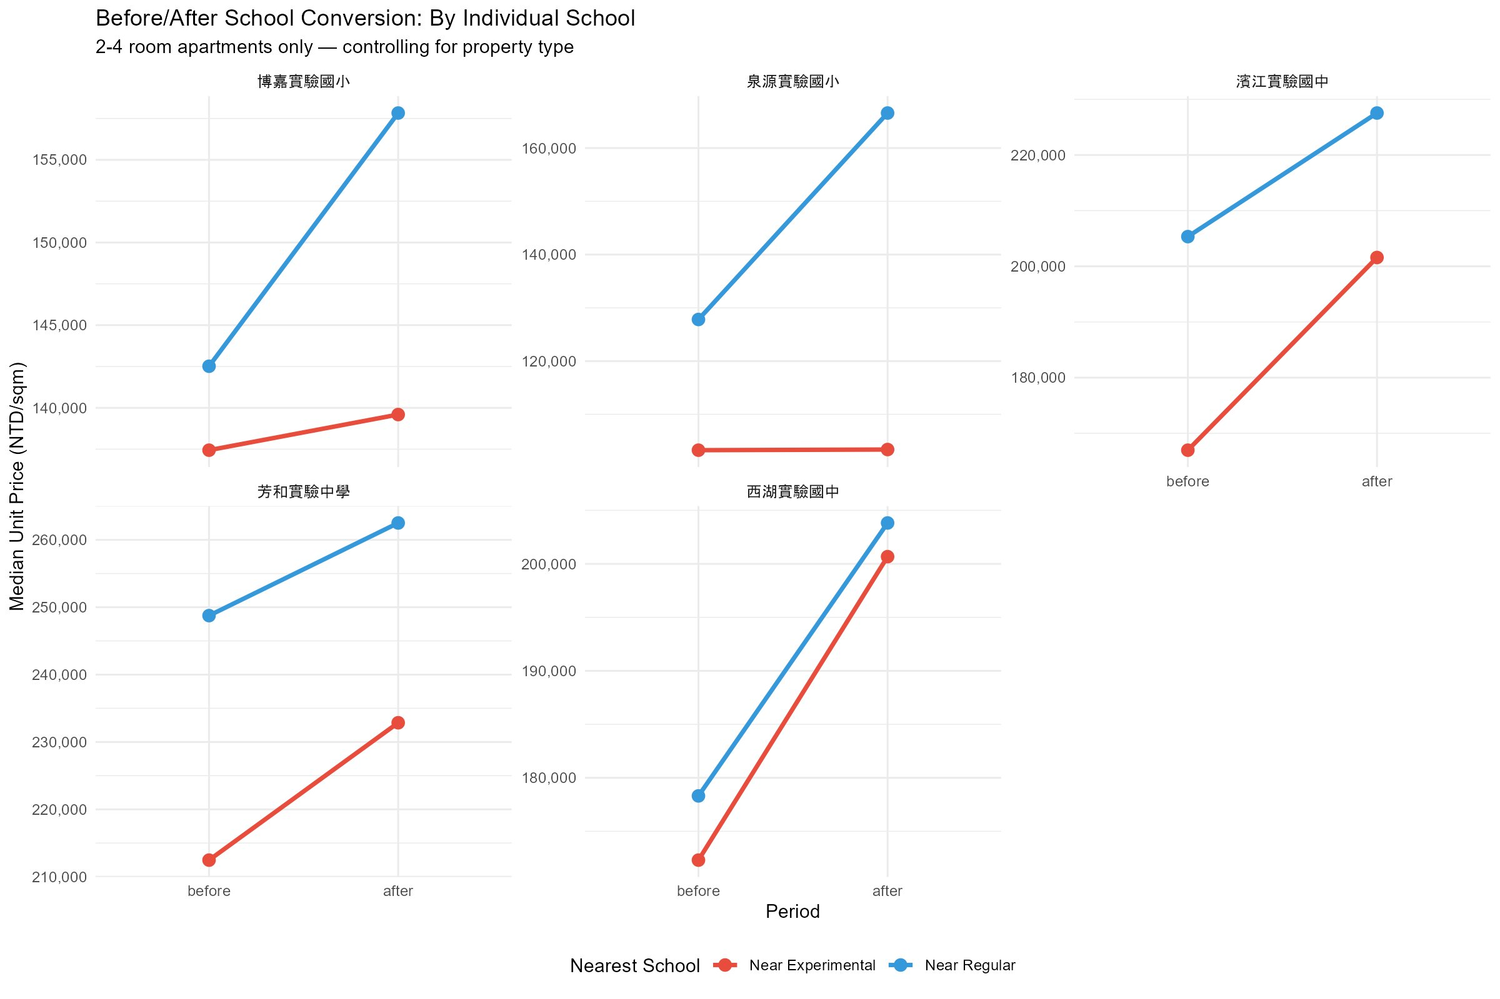
Figure 6: Before and after school conversion (matched apartments)

4.7 Difference-in-Differences (Key Finding)
Table 2 shows the core finding. The difference-in-differences (DiD) measures how much faster (or slower) experimental school areas grew compared to regular school areas after conversion. A positive DiD means the experimental area caught up or grew faster.

School | Exp Before | Exp After | Exp Gr% | Reg Before | Reg After | Reg Gr% | DiD
濱江實驗國中 | 166,966 | 201,583 | 20.7% | 205,334 | 227,535 | 10.8% | +9.9%
芳和實驗中學 | 212,465 | 232,854 | 9.6% | 248,756 | 262,508 | 5.5% | +4.1%
西湖實驗國中 | 172,307 | 200,673 | 16.5% | 178,309 | 203,822 | 14.3% | +2.2%
博嘉實驗國小 | 137,439 | 139,594 | 1.6% | 142,516 | 157,829 | 10.7% | -9.2%
泉源實驗國小 | 103,267 | 103,388 | 0.1% | 127,812 | 166,578 | 30.3% | -30.2%
Table 2: Difference-in-differences by school (median price per sqm, NTD)
Three schools show a positive DiD: Binjiang (+9.9 percentage points), Fanghe (+4.1), and Xihu (+2.2). This means properties near these experimental schools grew faster than properties near regular schools after the school converted. Although all five schools still show negative absolute price premiums (Figure 4), three show positive DiD values, meaning they remained cheaper than nearby regular school areas but appreciated faster after conversion. Binjiang's strong result may be partly because it is located in a desirable riverside area. Fanghe and Xihu show more modest effects.
Two schools show a negative DiD: Bojia (-9.2) and Quanyuan (-30.2). Quanyuan's extreme negative result is likely driven by its remote mountain location in Beitou with very few transactions. Bojia in Wenshan shows a small positive growth (+1.6%) but was outpaced by the surrounding regular school area (+10.7%).

5. Discussion
The results show a mixed picture. At the overall level, experimental and regular school areas have very similar price trends within the same district. There is no large, obvious premium for living near an experimental school.
However, the per-school DiD analysis tells a more interesting story. Three out of five schools show experimental areas appreciating faster after conversion. The strongest effect is at Binjiang (+9.9%), which is in an urban riverside area with good accessibility. The weakest positive effect is at Xihu (+2.2%), a more recently converted school. This suggests that the experimental school effect may exist but is modest and depends on the school's location and accessibility.
The two negative results (Bojia and Quanyuan) likely reflect the limitations of comparing in low-density areas rather than a genuine negative effect of experimental schools. Quanyuan in particular is located in the Beitou hills where very few transactions occur, making any comparison unreliable.
An important limitation is that some experimental and regular schools are very close together. For example, Fanghe and Gongguan ES are only 307m apart. In these cases, the catchment zone boundary does not cleanly separate the two schools, and the comparison may capture neighborhood-level trends rather than school-specific effects.

6. Limitations and Future Work
- Property coordinates are based on road centers, not exact building locations. This creates noise of about 200 to 500 meters.
- Four schools (Xishan, Hutian, Minzu, Zhinan) had too few transactions within the 1km radius and were excluded from the per-school analysis.
- Some experimental and regular schools are less than 500m apart, creating potential overlap in catchment zones.
- This analysis shows association, not causation. New construction, infrastructure changes, or demographic shifts could also affect prices.
- Before and after periods differ by school because conversion dates range from 2017 to 2022.

Future work could use exact address geocoding through Taiwan's TGOS service, implement paired one-to-one school matching with non-overlapping zones, and extend the analysis to New Taipei City experimental schools.

7. Conclusion
This study examined whether housing prices near experimental schools in Taipei have increased faster than prices near regular schools. Using 170,551 real estate transactions, geocoded school locations, and proximity-based catchment zone analysis, we find mixed results.
At the overall level, experimental and regular school areas show similar price trends. At the per-school level, 3 out of 5 schools with sufficient data show experimental areas appreciating faster after conversion (Binjiang +9.9%, Fanghe +4.1%, Xihu +2.2%). Two schools show the opposite (Bojia -9.2%, Quanyuan -30.2%).
The effect appears to depend on the school's location: urban, accessible schools show positive effects while remote schools do not. We cannot claim causation, but the pattern is consistent with growing parental demand for housing near experimental schools in areas where that demand can translate into price pressure.

References
Ministry of the Interior, Taiwan. Real Price Registration System. plvr.land.moi.gov.tw
K12 Education Administration, Ministry of Education, Taiwan. k12ea.gov.tw
Ministry of Education, Taiwan. School Directory Data. data.gov.tw/dataset/6087, data.gov.tw/dataset/6089
Wickham, H. et al. (2019). Welcome to the tidyverse. JOSS, 4(43), 1686.
Hijmans, R. J. (2022). geosphere: Spherical Trigonometry. R package.

